Do you know Great Britain and The USA?
(викторина для учащихся 5-7 классов)
Task 1. Find the odd word.
- Peach, pear, chicken, apple, banana.
- Tail, cat, mouse, dog, rabbit.
- Bird, airplane, kite, helicopter, bus.
- Red, sun, green, purple, brown.
- Cold, warm, dry, sky, cloudy.

Task 2. Choose the correct answer.
- London stands on the…
- Thames
- Severn
- Avon
- The Queen’s official London home is…..
- The Tower of London
- Windsor Castle
- Buckingham Palace
- What do the English often put in the tea?
- Jam
- Fruit
- Milk
- Taxis in London are usually…
- Green
- Yellow
- Black
- Who wrote stories about the famous detective Sherlock Holmes?
- Sir Arthur Conan Doyle
- Agatha Christie
- Daniel Defoe
- Where do men wear kilt?
- In England
- In Wales
- In Scotland

- What are the colours of the British flag?
- Blue, red, white
- White, blue, brown
- Red, green, black
- Which holidays is on December 25?
- St. Valentine’s Day
- Christmas
- Easter
- A famous wax works museum in London is….
- MOMI
- The British Museum
- Madame Tussaud’s museum
- Daniel Defoe was a famous English…
- Poet
- Artist
- Writer
- The USA is divided into … states.
- 50
- 49
- 51
- Who is the head of the country?
- The King or the Queen
- The President
- The Prime Minister
- The capital of the USA is….
- New York
- Washington
- Los Angeles

Task 3. Crossward
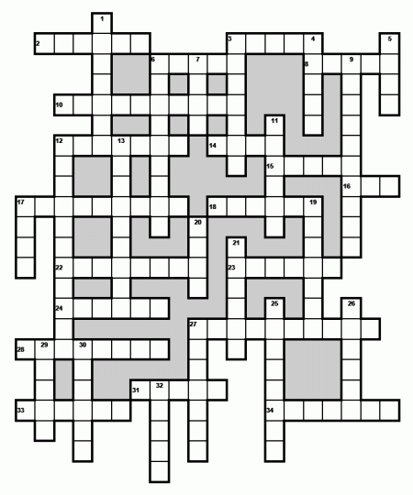

Down:
1. Lord Nelson was an ...... .
3. London is the capital of Great ...... .
4. A ...... is one of the large black birds that live in the Tower of London.
5. The largest park in London is ...... Park.
6. ...... Square is in the centre of London.
7. The famous English architect Sir Christopher ...... built a lot of churches in London.
9. ...... Square is the literary part of the city. Many writers and critics live there.
11. In the middle of Trafalgar Square is a monument to Lord ...... .
12. The political centre of London is ...... .
13. The name of London in Roman times was ...... .
17. The ...... is the oldest part of London. There are a lot of banks and offices there.
19. The British Prime Minister lives at number 10 ...... Street.
20. Big Ben got its name after Sir Benjamin ...... .
21. Before William the Conqueror came to England he lived in ...... .
25. In front of Buckingham Palace is the Queen ...... Memorial.
26. The Tower of London was a fortress, a ......, a prison and the King's Zoo.
27. The ...... Museum was founded in 1753.
29. One of the famous London cinemas is the ...... .
30. Now the Tower of London is a ...... . You can see a lot of interesting things there.
32. The Royal ...... House is in the centre of the former fruit and vegetable market.
Across:
2. Until 1749, there was only one bridge over the Thames: ...... Bridge.
3. The Great Fire of London started in the house of the king's ...... .
6. William the Conqueror built the White ...... to live in it.
8. Westminster ...... is one of the most famous churches in London. it is more than 900 years old.
10. In Westminster you can see a long grey building with towers which is the Houses of ...... .
12. ...... the Conqueror came to England in 1066.
14. On 2nd September 1666 the Great ...... of London began.
15. There are four bronze ...... at the foot of Nelson's Column.
16. Big ...... is the name of the clock and the bell in the clock tower of the Houses of Parliament.
17. It took 35 years to build St. Paul's ...... .
18. ...... Street is London's main shopping centre.
22. There are two fountains in front of the ...... Gallery, which is one of the best picture galleries in the world.
23. The ...... left Britain soon after 400.
24. London stands on the River ...... .
27. The Queen of England lives in ...... Palace.
28. William the Conqueror came to England from ...... .
31. Many great writers are buried in the ......' Corner in Westminster Abbey.
33. ...... Garden is one of the most famous London theatres.
34. The British Museum is in Great ...... Street.

